CLOUD COMPUTING LAB EXPERIMENTS

Experiment 1 – Flight Reservation System
Aim
To create a simple cloud-based Flight Reservation System using a Cloud Service Provider to demonstrate the concept of Software as a Service (SaaS).
Procedure
- Open VS Code.
- Create a new file named index.html.
- Copy and paste the code given below.
- Save the file.
- Open index.html in Google Chrome.
- Enter the flight reservation details.
- Click Search Flights.
- The entered details will be displayed as a booking summary.
- The application can be uploaded to a cloud service such as GitHub Pages to demonstrate SaaS.
- The application can then be accessed through a web browser.
OUTPUT: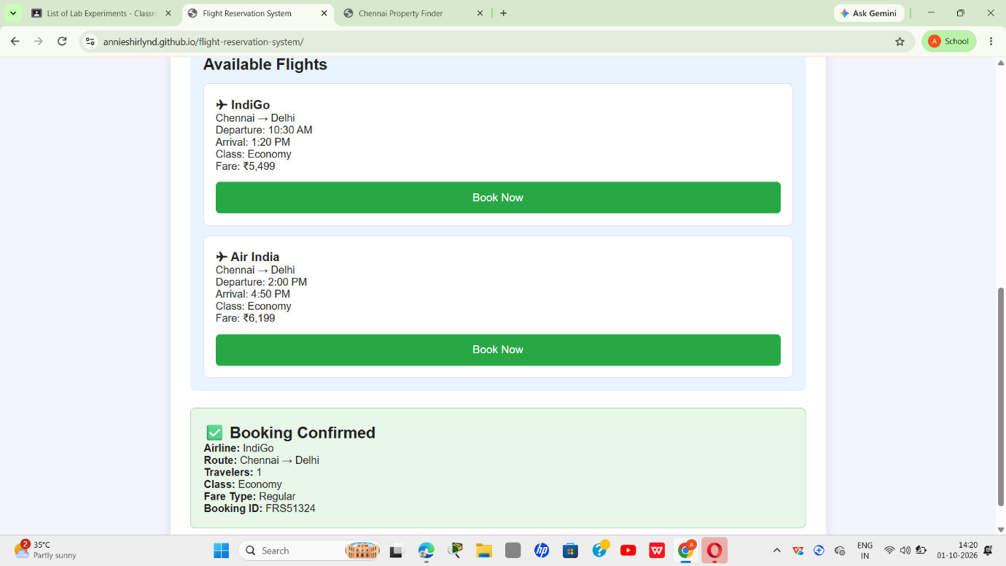
Result
Thus, a simple cloud-based Flight Reservation System was successfully created. The system accepts flight search and reservation details and displays the booking information through a web interface, demonstrating the basic concept of Software as a Service (SaaS).

Experiment 2: Property Buying & Rental Process – SaaS
Aim
To create a simple cloud-based Property Buying and Rental application for Chennai city using a Cloud Service Provider, demonstrating the basic concept of Software as a Service (SaaS).
Procedure
- Open VS Code or any online HTML editor.
- Create a new file named index.html.
- Copy the code below into the file.
- Save the file.
- Open index.html in Google Chrome.
- Enter the property details.
- Click Search Property.
- The application displays the entered property details and a confirmation message.
- For SaaS demonstration, the HTML application can be hosted on a cloud service such as GitHub Pages.
OUTPUT: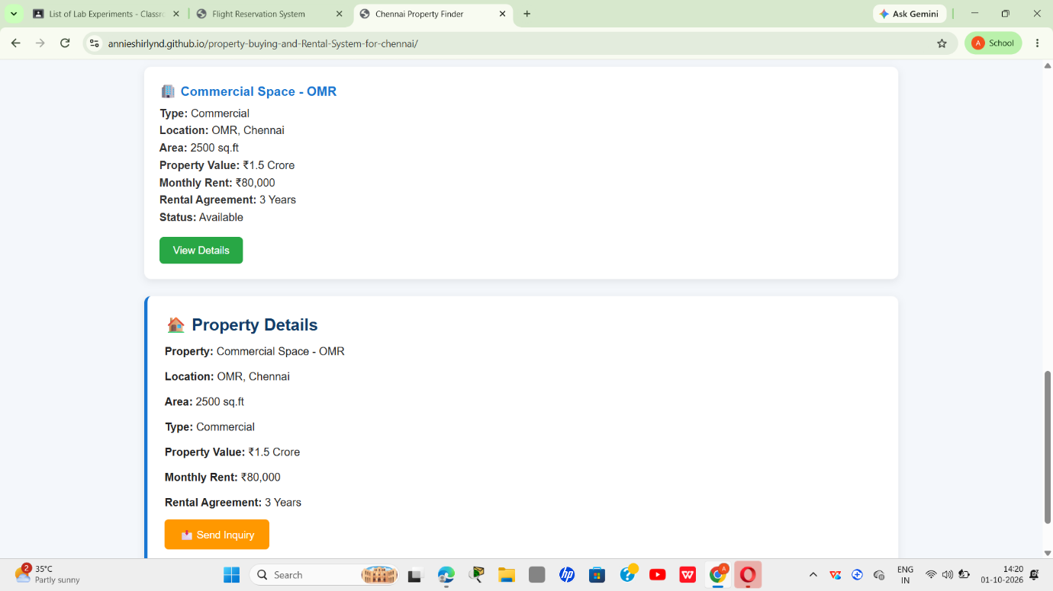
Result
Thus, a simple cloud-based Property Buying and Rental SaaS application for Chennai city was successfully created. The application accepts property details and displays the selected property information through a web interface.

Experiment 3 – Car Booking Reservation System
Aim
To create a simple cloud-based Car Booking Reservation System using a Cloud Service Provider to demonstrate the concept of Software as a Service (SaaS).
Procedure
- Open VS Code.
- Create a file named index.html.
- Enter the code given below.
- Save the file.
- Open the file using Google Chrome.
- Enter the car booking details.
- Click Book Cab.
- The entered booking information will be displayed.
- The application can be hosted on a cloud service such as GitHub Pages to demonstrate SaaS.

OUTPUT:
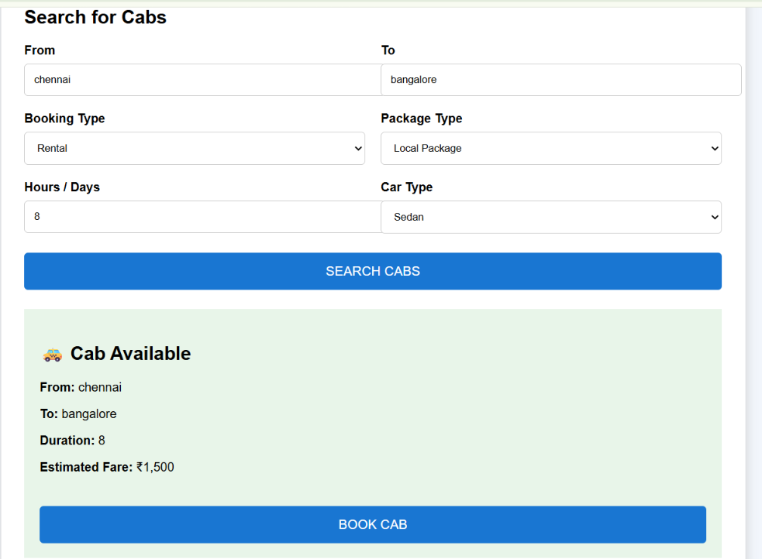

Result:
Thus, a simple cloud-based Car Booking Reservation System was successfully created and the booking details were displayed using a web application.

Experiment 4 – SIMATS Library Book Reservation System
Aim
To create a simple cloud-based Library Book Reservation System for SIMATS Library using a Cloud Service Provider to demonstrate Software as a Service (SaaS).
Procedure
- Open VS Code.
- Create a file named index.html.
- Enter the code below.
- Save the file.
- Open the file in Chrome.
- Enter the book details.
- Click Reserve Book.
- The application displays the reservation details.
- Host the application on a cloud service such as GitHub Pages to demonstrate SaaS.

OUTPUT:
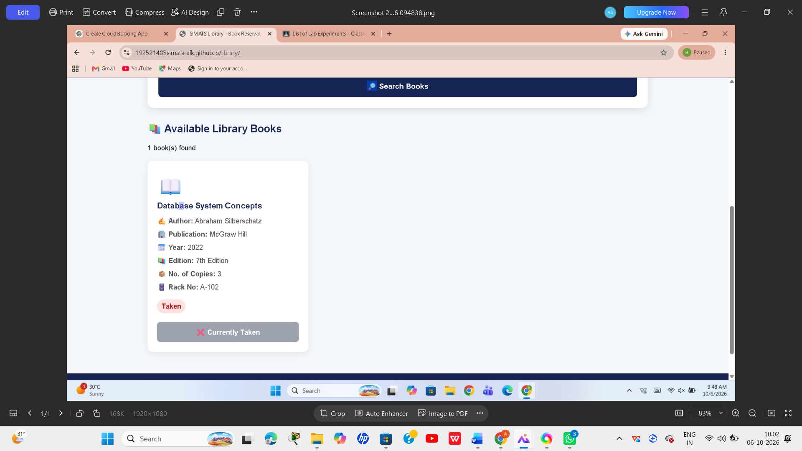
Result
Thus, a simple cloud-based SIMATS Library Book Reservation System was successfully developed to enter, display and reserve library book information.

Experiment 5 – Mark Sheet Processing System
Aim
To create a simple cloud-based Mark Sheet Processing System using a Cloud Service Provider to demonstrate Software as a Service (SaaS).
Procedure
- Open VS Code.
- Create a file named index.html.
- Enter the code below.
- Save the file.
- Open it in Google Chrome.
- Enter the student's name and register number.
- Enter marks for each subject.
- Click Generate Mark Sheet.
- The system automatically calculates the total, average and percentage.
- The result is displayed on the screen.
- The application can be hosted on a cloud platform to demonstrate SaaS.

OUTPUT:
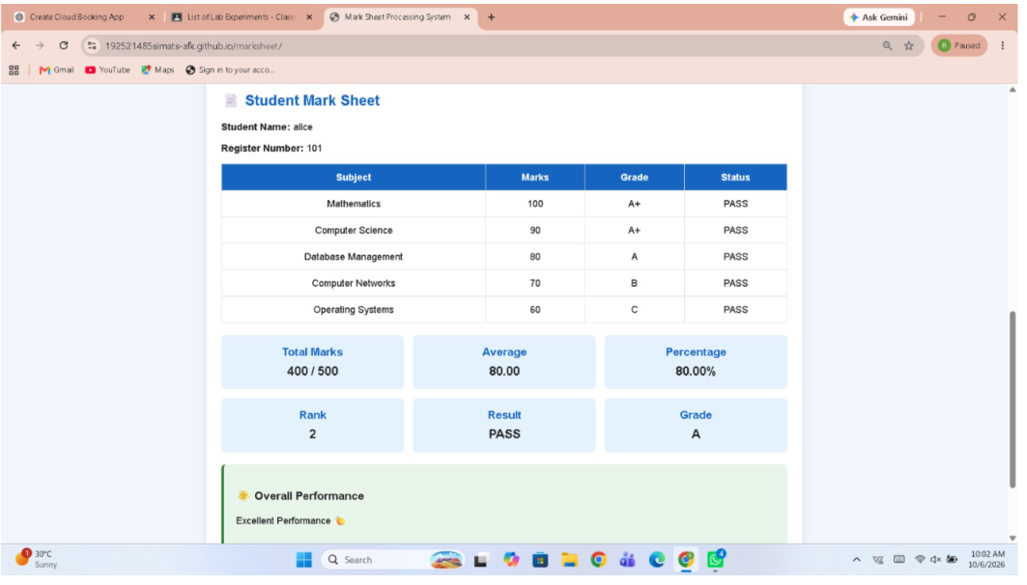
Result
Thus, a simple cloud-based Mark Sheet Processing System was successfully developed. The system accepts student marks and automatically calculates the total, average, percentage and overall performance.

Experiment 6 – Payroll Processing
Aim
To create a simple payroll processing application that calculates the gross pay, deductions, and net pay of an employee.
Procedure
- Enter the employee details.
- Enter Basic Pay, HRA, DA, and TA.
- Calculate Gross Pay.
- Enter the deduction amount.
- Calculate Net Pay.
- Display the employee payroll details.
Calculation
Gross Pay = Basic Pay + HRA + DA + TA
= ₹40,000 + ₹8,000 + ₹4,000 + ₹3,000
= ₹55,000
Net Pay = Gross Pay − Deduction
= ₹55,000 − ₹4,000
= ₹51,000
OUTPUT:
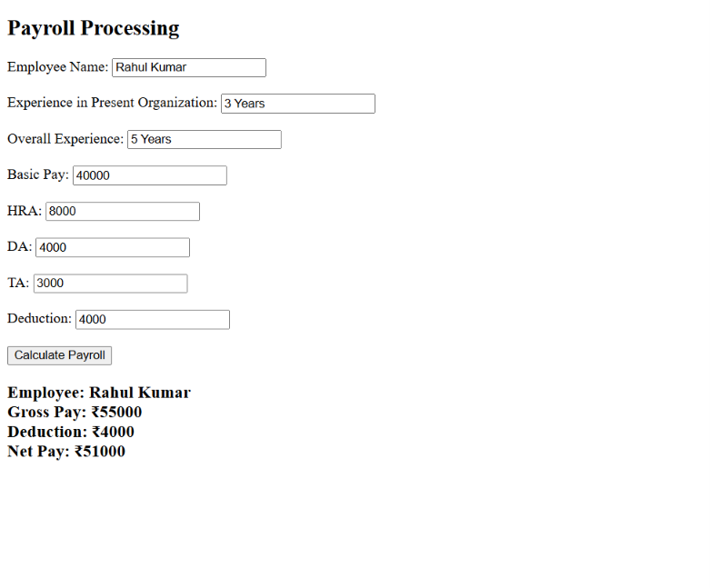
Result:
Thus, the payroll processing application was successfully created and the employee's Net Pay is ₹51,000.
Experiment 7 – Student Attendance
Aim
To create a student attendance application that calculates attendance percentage and determines the student's attendance status.
Procedure
- Enter the student's name and course.
- Enter the number of present days.
- Enter the number of absent days.
- Calculate the total working days.
- Calculate the attendance percentage.
- Display the attendance status.
Calculation
Total Days = Present + Absent
= 45 + 8
= 50 days
Attendance = (Present / Total Days) × 100
= (45 / 80) × 100
= 84.91%
OUTPUT:
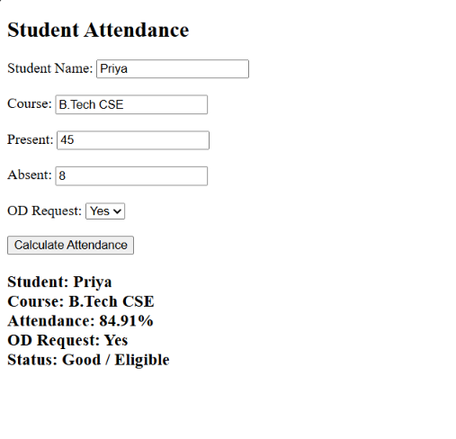
Result
Thus, the student attendance application was successfully created and Priya's attendance was calculated as 90%.
Experiment 8 – Student Counselling
Aim
To create a student counselling information system that stores student academic, personal, and career-interest details.
Procedure
- Enter the student's personal information.
- Enter the subjects studied.
- Enter the year of passing.
- Enter the student's percentage.
- Select the student's preferred domain.
- Display the counselling information.
OUTPUT:
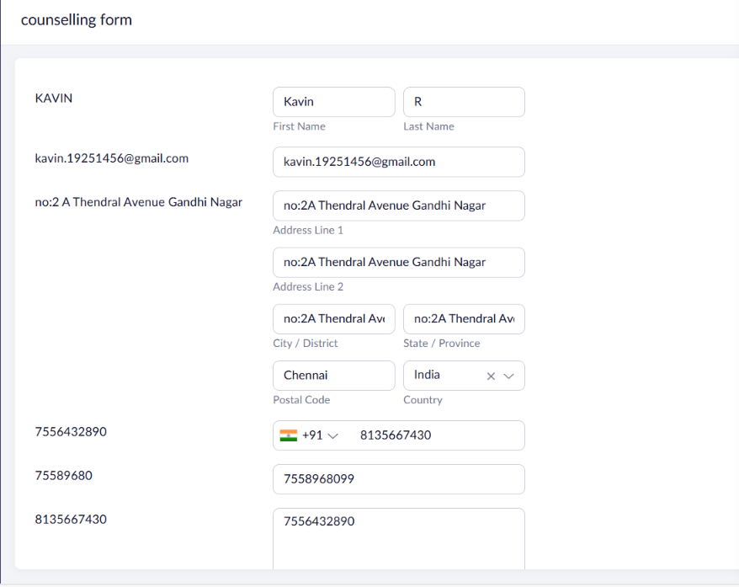Result
Thus, the student counselling application was successfully created to store and display the student's academic and career information.
Experiment 9 – SIMATS Hospital Information System
Aim
To create a simple hospital information system for storing patient, attender, doctor, and complaint details.
Procedure
- Enter the patient's personal details.
- Enter the patient's contact information.
- Enter the attender's details.
- Enter the consulting doctor's name.
- Enter the patient's disease or complaint.
- Store and display the information.
OUTPUT:
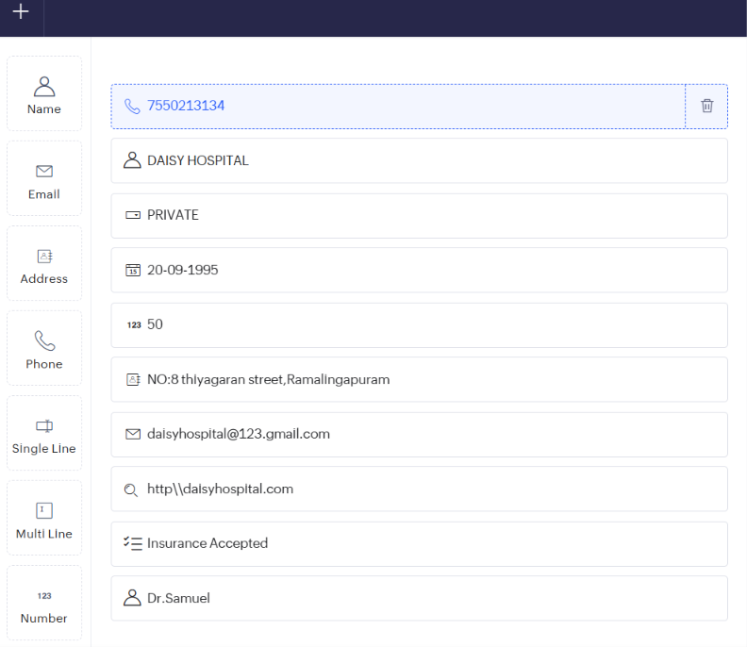

Result
Thus, the SIMATS Hospital Information System was successfully created to store and display patient and hospital information.
Experiment 10 – C Program – Student Information
Aim
To develop a C program that stores and displays student personal, academic, attendance, and performance information.
Procedure:
- Open Zoho Creator and select your application.
- Click Edit this application → + → Form → Create from Scratch.
- Name the form Student Information.
- Add fields: Name, Register Number, Address, Phone, Age, Courses, Grades, Attendance, Performance, Total Marks, Percentage, Semester Grade.
- Enter the sample student details.
- Click Save/Submit.
- Open the Report to view the student information.

OUTPUT:
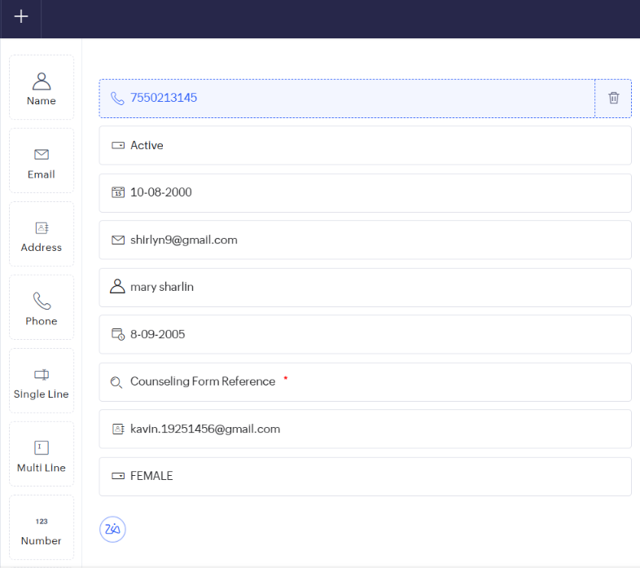
Result:
Student Information System was successfully created using Zoho Creator.

